DIGITAL SYSTEM DESIGN LABORATORY
REPORT LAB 5

SINGLE CYCLE MICROPROCESSOR DATAPATH DESIGN

Name: Bùi Gia Bảo
ID: ITITIU22019

I. LAB OBJECTIVES

This Lab experiments are intended to design and test a Single Cycle Microprocessor

II. DESCRIPTION

Single Cycle Microprocessor datapath to be implemented is in figure 2.1.

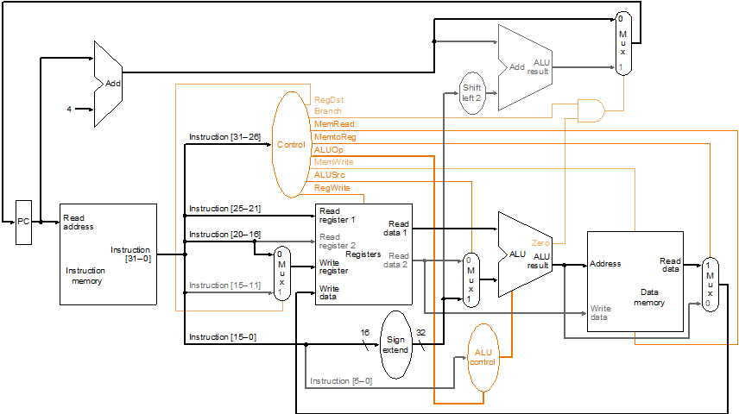

Figure 2.1: Single Cycle Microprocessor DataPath

III. LAB PROCEDURE

III.1 EXPERIMENT NO. 1

III.1.1 AIM: To understand and write the assembly code using MIPS Instruction set

register number of MIPS compiler conventions

MIPS Assembly Language Sumarize:

Operation code (Op code) sumarize:
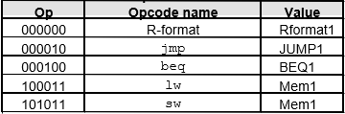
ALU opcode and Function
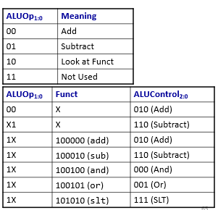

Instruction Formats
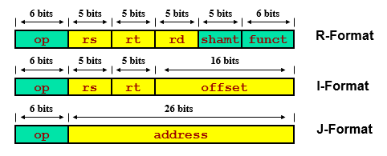

III.1.2 CODE
a) Assembly Code sample 1:
Instruction Meaning

addi $s0, $zero, 33 load immediate value 33 to register $s0
addi $s1, $zero, 66 load immediate value 66 to register $s1
add $s2, $s0, $s1 $s2 = $s0 + $s1
sub $s3, $s1, $s0 $s1 = $s1 – $s0
sw $s3, 10($s2) Memory[$s2+10] = $s3
lw $s1, 10($s2) $s1 = Memory[$s2+10]
b) Assembly Code sample 2:

Assume the code start from address PC=0x00000000, one instruction is store in one memory location.
Instruction Meaning
addi $s2, $zero, 55 load immediate value 55 to register $S2
addi $s3, $zero, 22 load immediate value 22 to register $S3
addi $s5, $zero, 33 load immediate value 55 to register $S3
add $s4,$s2,$s3 $s4 = $s2 + $s3
sub $s1,$s2,$s3 $s1 = $s2 – $s3
sw $s1,100($s2) Memory[$s2+100] = $s1
lw $s1,100($s2) $s1 = Memory[$s2+100]
bne $s1,$s5,End Next instr. is at End if $s4 !=$s5
addi $s6, $zero, 10 load immediate value 10 to register $s6
beq $s4,$s5, End Next instr. is at End if $s4 = $s5
addi $s6, $zero, 20 load immediate value 20 to register $s6
End: j End jump Here

III.1.3 LAB ASSIGNMENT
a) Compile the Assembly Assembly Code sample 1 into machine code (decimal code and binary code)
b) Explain briefly the meaning of Assembly Code sample 1

c) Compile the Assembly Assembly Code sample 2 into machine code (decimal code and binary code)
d) Explain briefly the meaning of Assembly Code sample 2

III.2 EXPERIMENT NO. 2

III.2.1 AIM: To implement R-Type Datapath

Given the assembly code
addi $s1, $zero, 33 load immediate value 33 to register $s0
addi $s2, $zero, 66 load immediate value 66 to register $s1

add $s0, $s1, $s2 $s0 = $s1 + $s2

Translate into Macchine code:

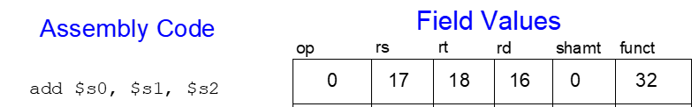

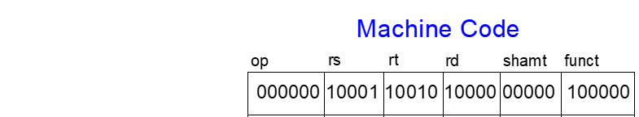

Modify the code register file:

Assign initial value of the register 17=33 ( $s1=33)

Assign initial value of the register 18=33 ( $s2=66)

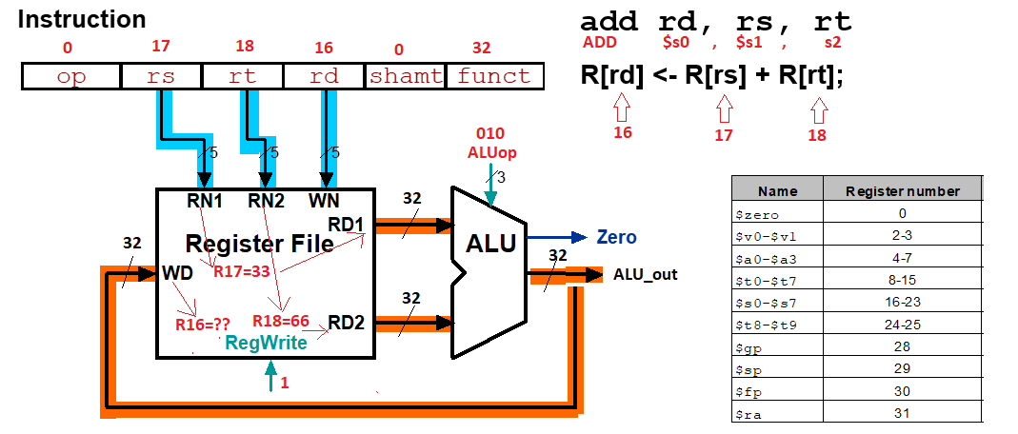

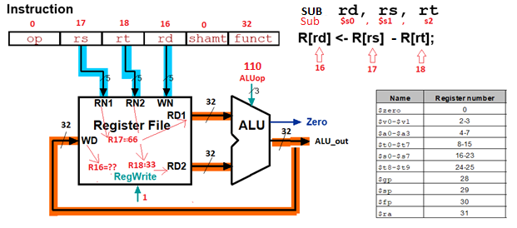
III.2.2 CODE
module lab5_ex2(KEY,SW,LEDG,LEDR,HEX0,HEX1,HEX2,HEX3,HEX4,HEX5,HEX6,HEX7);
input[3:0] KEY;
input [17:0] SW;
output [17:0] LEDR;
output [7:0] LEDG;

output [0:6] HEX0,HEX1,HEX2,HEX3,HEX4,HEX5,HEX6,HEX7;
wire [31:0] w_hex;
assign LEDR =SW;

wire [2:0] op;
//assign op = SW[17] ? 3'b010 : 3'b110;

DatapathR_Type_Add(.rs(SW[14:10]), .rt(SW[9:5]), .rd(SW[4:0]),
.ALUop(SW[17:15]),
.Zero(LEDG[7]),
.ALU_out(w_hex),
.reset(KEY[0]),
.clk(KEY[1]),
.regWrite(1'b1));

HEX_7SEG_DECODE H0(.BIN(w_hex[3:0]), .SSD(HEX0));
HEX_7SEG_DECODE H1(.BIN(w_hex[7:4]), .SSD(HEX1));
HEX_7SEG_DECODE H2(.BIN(w_hex[11:8]), .SSD(HEX2));
HEX_7SEG_DECODE H3(.BIN(w_hex[15:12]), .SSD(HEX3));
HEX_7SEG_DECODE H4(.BIN(w_hex[19:16]), .SSD(HEX4));
HEX_7SEG_DECODE H5(.BIN(w_hex[23:20]), .SSD(HEX5));
HEX_7SEG_DECODE H6(.BIN(w_hex[27:24]), .SSD(HEX6));
HEX_7SEG_DECODE H7(.BIN(w_hex[31:28]), .SSD(HEX7));

endmodule

module DatapathR_Type_Add(rs, rt, rd,ALUop, Zero ,ALU_out, reset, clk, regWrite);
input[4:0] rs, rt, rd;
input[2:0] ALUop;
output Zero;
output[31:0] ALU_out;
wire[31:0] w_rd_1, w_rd_2, w_rd_11, w_rd_22;
input clk;
input reset;
input regWrite;

assign w_rd_11 = 32'h0000_0003;
assign w_rd_22 = 32'h0000_0001;

Register_File ( .read_addr_1(rs),
.read_addr_2(rt),
.write_addr(rd),
.read_data_1(w_rd_1),
.read_data_2(w_rd_2),
.write_data(ALU_out),
.RegWrite(regWrite),
.clk(clk),
.reset(reset));

alu( .alufn(ALUop),
.ra(w_rd_1),
.rb_or_imm(w_rd_2),
.aluout(ALU_out),
.zero(Zero));

endmodule

module HEX_7SEG_DECODE(BIN, SSD);
input [3:0] BIN;
output reg [0:6] SSD;
always begin
case(BIN)
0:SSD=7'b0000001;
1:SSD=7'b1001111;
2:SSD=7'b0010010;
3:SSD=7'b0000110;
4:SSD=7'b1001100;
5:SSD=7'b0100100;
6:SSD=7'b0100000;
7:SSD=7'b0001111;
8:SSD=7'b0000000;
9:SSD=7'b0001100;
10:SSD=7'b0001000;
11:SSD=7'b1100000;
12:SSD=7'b0110001;
13:SSD=7'b1000010;
14:SSD=7'b0110000;
15:SSD=7'b0111000;
endcase
end
endmodule

module Register_File (read_addr_1, read_addr_2, write_addr, read_data_1, read_data_2, write_data, RegWrite, clk, reset);
input [4:0] read_addr_1, read_addr_2, write_addr;
input [31:0] write_data;
input clk, reset, RegWrite;
output [31:0] read_data_1, read_data_2;

reg [31:0] Regfile [31:0];
integer k;

//assign Regfile[17] = 32'h33;
//assign Regfile[18] = 32'h66;

assign read_data_1 = RegWrite ? Regfile[read_addr_1] : 32'b0;

assign read_data_2 = RegWrite ? Regfile[read_addr_2] : 32'b0;

always @(posedge clk or negedge reset)
begin
if (reset==1'b0)
begin
for (k=0; k<32; k=k+1)
begin
Regfile[k] = 32'b0;
end
end

else begin
if (RegWrite == 1'b1) Regfile[write_addr] = write_data;
Regfile[17] = 32'h33;
Regfile[18] = 32'h66;
end

end

endmodule

module alu(
input [2:0] alufn,
input [31:0] ra,
input [31:0] rb_or_imm,
output reg [31:0] aluout,
output wire zero);

parameter ALU_OP_ADD = 3'b010,
ALU_OP_SUB = 3'b110,
ALU_OP_AND = 3'b000,
ALU_OP_OR = 3'b001,
ALU_OP_NOT_A = 3'b100,
ALU_OP_LW = 3'b101,
ALU_OP_SW = 3'b011,
ALU_OP_BEQ = 3'b111;

assign zero = ((alufn == ALU_OP_BEQ) && (ra==rb_or_imm))?1'b1:1'b0;
always @(*)
begin
case(alufn)
ALU_OP_ADD : aluout = ra + rb_or_imm;
ALU_OP_SUB : aluout = ra - rb_or_imm;
ALU_OP_AND : aluout = ra & rb_or_imm;
ALU_OP_OR : aluout = ra | rb_or_imm;
ALU_OP_NOT_A : aluout = ~ ra;
ALU_OP_LW : aluout = ra + rb_or_imm;
ALU_OP_SW : aluout = ra + rb_or_imm;
ALU_OP_BEQ : aluout = ra - rb_or_imm;
endcase
end
endmodule

III.3 EXPERIMENT NO. 3

III.3.1 AIM: To implement SW I-Type Instruction Datapath

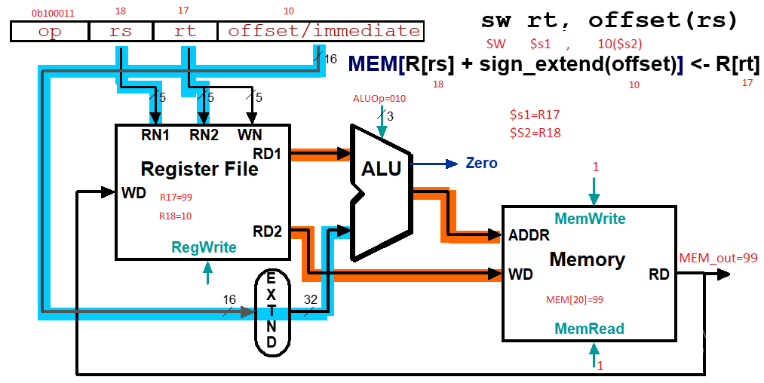

III.3.2 CODE
module lab5_ex3(KEY,SW,LEDG,LEDR,HEX0,HEX1,HEX2);
input[3:0] KEY;
input [17:0] SW;
output [17:0] LEDR;
output [7:0] LEDG;

output [0:6] HEX0,HEX1,HEX2;
wire [7:0] w_hex,w_hex_2;
assign LEDR =SW;

//assign op = SW[17] ? 3'b010 : 3'b110;

SW_datapath ( .rs(SW[2:0]),
.rt(SW[5:3]),
.offset(SW[10:6]),
.ALUop(SW[13:11]),
.MemWrite(SW[14]),
.MemRead(SW[15]),
.Mem_out(w_hex),
.reset(SW[17]),
.clk(KEY[1]),
.regWrite(1'b1));

HEX_7SEG_DECODE H0(.BIN(w_hex[3:0]), .SSD(HEX0));
HEX_7SEG_DECODE H1(.BIN(w_hex[7:4]), .SSD(HEX1));

endmodule

module SW_datapath (rs, rt, offset,ALUop,MemWrite,MemRead,Mem_out, reset, clk, regWrite);

input[2:0] rs, rt;
input[2:0] ALUop;
input[4:0] offset;
input MemWrite, MemRead;
output[7:0] Mem_out;

wire[7:0] ALU_out;
wire[7:0] w_rd_1, w_rd_2, w_rd_11, w_rd_22;
wire[7:0] w_mrd, w_offset_ext;

input clk;
input reset;
input regWrite;

Register_File ( .read_addr_1(rs),
.read_addr_2(rt),
.write_addr(rt),
.read_data_1(w_rd_1),
.read_data_2(w_rd_2),
.write_data(8'b00000000),
.RegWrite(regWrite),
.clk(clk),
.reset(reset));

alu( .alufn(ALUop),
.ra(w_rd_1),
.rb_or_imm(w_offset_ext),
.aluout(ALU_out),
.zero(Zero));

Data_Memory ( .addr(ALU_out),
.write_data(w_rd_2),
.read_data(Mem_out),
.clk(clk),
.reset(reset),
.MemRead(MemRead),
.MemWrite(MemWrite));

Sign_Extension (.sign_in(offset), .sign_out(w_offset_ext));

endmodule

module HEX_7SEG_DECODE(BIN, SSD);
input [3:0] BIN;
output reg [0:6] SSD;
always begin
case(BIN)
0:SSD=7'b0000001;
1:SSD=7'b1001111;
2:SSD=7'b0010010;
3:SSD=7'b0000110;
4:SSD=7'b1001100;
5:SSD=7'b0100100;
6:SSD=7'b0100000;
7:SSD=7'b0001111;
8:SSD=7'b0000000;
9:SSD=7'b0001100;
10:SSD=7'b0001000;
11:SSD=7'b1100000;
12:SSD=7'b0110001;
13:SSD=7'b1000010;
14:SSD=7'b0110000;
15:SSD=7'b0111000;
endcase
end
endmodule

module Register_File (read_addr_1, read_addr_2, write_addr, read_data_1, read_data_2, write_data, RegWrite, clk, reset);
input [2:0] read_addr_1, read_addr_2, write_addr;
input [7:0] write_data;
input clk, reset, RegWrite;
output [7:0] read_data_1, read_data_2;

reg [7:0] Regfile [7:0];
integer k;

assign read_data_1 = RegWrite ? Regfile[read_addr_1] : 8'b0;

assign read_data_2 = RegWrite ? Regfile[read_addr_2] : 8'b0;

always @(posedge clk or negedge reset)
begin
if (reset==1'b0)
begin
for (k=0; k<8; k=k+1)
begin
Regfile[k] = 8'b0;
end
end

else begin
if (RegWrite == 1'b1) Regfile[write_addr] = write_data;
Regfile[3] = 8'h1;
Regfile[5] = 8'h2;
Regfile[6] = 8'h3;
Regfile[4] = 8'h2;
end

end

endmodule

module alu(
input [2:0] alufn,
input [7:0] ra,
input [7:0] rb_or_imm,
output reg [7:0] aluout,
output wire zero);

parameter ALU_OP_ADD = 3'b010,
ALU_OP_SUB = 3'b110,
ALU_OP_AND = 3'b000,
ALU_OP_OR = 3'b001,
ALU_OP_NOT_A = 3'b100,
ALU_OP_LW = 3'b101,
ALU_OP_SW = 3'b011,
ALU_OP_BEQ = 3'b111;

assign zero = ((alufn == ALU_OP_BEQ) && (ra==rb_or_imm))?1'b1:1'b0;
always @(*)
begin
case(alufn)
ALU_OP_ADD : aluout = ra + rb_or_imm;
ALU_OP_SUB : aluout = ra - rb_or_imm;
ALU_OP_AND : aluout = ra & rb_or_imm;
ALU_OP_OR : aluout = ra | rb_or_imm;
ALU_OP_NOT_A : aluout = ~ ra;
ALU_OP_LW : aluout = ra + rb_or_imm;
ALU_OP_SW : aluout = ra + rb_or_imm;
ALU_OP_BEQ : aluout = ra - rb_or_imm;
endcase
end
endmodule

module Data_Memory (addr, write_data, read_data, clk, reset, MemRead, MemWrite);
input [7:0] addr;
input [7:0] write_data;
output [7:0] read_data;
input clk, reset, MemRead, MemWrite;
reg [7:0] DMemory [7:0];
integer k;
assign read_data = (MemRead && ~MemWrite) ? DMemory[addr] : 8'bx;

always @(posedge clk or negedge reset)
begin
if (reset == 1'b0)
begin
for (k=0; k<8; k=k+1)
begin
DMemory[k] = 8'b0;
end
end
else
if (MemWrite) DMemory[addr] = write_data;
end
endmodule

module Sign_Extension (sign_in, sign_out);
input [4:0] sign_in;
output [7:0] sign_out;
assign sign_out[4:0]=sign_in[4:0];
assign sign_out[7:5]=sign_in[4]?{3{1'b1}}:3'b0;
endmodule

III.4 EXPERIMENT NO. 4

III.4.1 AIM: To implement LW I-Type Instruction Datapath

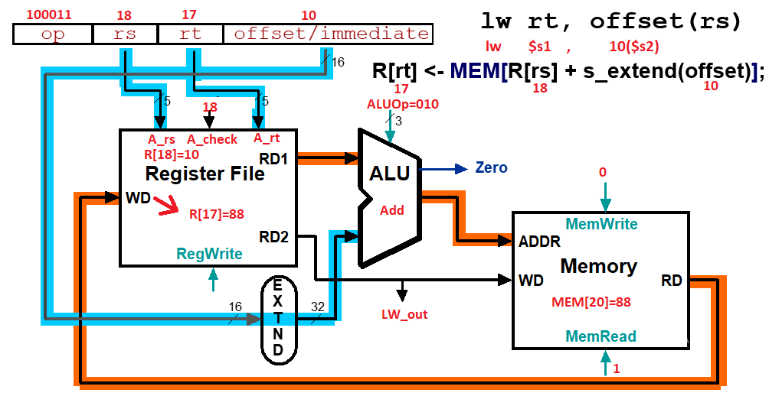
III.4.2 CODE
module lab5_ex4(KEY,SW,LEDG,LEDR,HEX0,HEX1,HEX2);
input[3:0] KEY;
input [17:0] SW;
output [17:0] LEDR;
output [7:0] LEDG;

output [0:6] HEX0,HEX1,HEX2;
wire [7:0] w_hex,w_hex_2;
assign LEDR =SW;

LW_datapath ( .rs(SW[2:0]),
.rt(SW[5:3]),
.offset(SW[10:6]),
.ALUop(SW[13:11]),
.MemWrite(SW[14]),
.MemRead(SW[15]),
.LW_out(w_hex),
.reset(SW[17]),
.clk(KEY[1]),
.regWrite(1'b1));

HEX_7SEG_DECODE H0(.BIN(w_hex[3:0]), .SSD(HEX0));
HEX_7SEG_DECODE H1(.BIN(w_hex[7:4]), .SSD(HEX1));

endmodule

module LW_datapath (rs, rt, offset, ALUop,MemWrite,MemRead, LW_out, reset, clk, regWrite);

input[2:0] rs, rt;
input[2:0] ALUop;
input[4:0] offset;
input MemWrite, MemRead;
output[7:0] LW_out;

wire[7:0] ALU_out;
wire[7:0] w_rd_1, w_rd_2, w_rd_11, w_rd_22;
wire[7:0] w_mrd, w_offset_ext;

input clk;
input reset;
input regWrite;

Register_File ( .read_addr_1(rs),
.read_addr_2(rt),
.write_addr(rt),
.read_data_1(w_rd_1),
.read_data_2(w_rd_2),
.write_data(LW_out),
.RegWrite(regWrite),
.clk(clk),
.reset(reset));

alu( .alufn(ALUop),
.ra(w_rd_1),
.rb_or_imm(w_offset_ext),
.aluout(ALU_out),
.zero(Zero));

Data_Memory ( .addr(ALU_out),
.write_data(8'b0000000),
.read_data(LW_out),
.clk(clk),
.reset(reset),
.MemRead(MemRead),
.MemWrite(MemWrite));

Sign_Extension (.sign_in(offset), .sign_out(w_offset_ext));

endmodule

module HEX_7SEG_DECODE(BIN, SSD);
input [3:0] BIN;
output reg [0:6] SSD;
always begin
case(BIN)
0:SSD=7'b0000001;
1:SSD=7'b1001111;
2:SSD=7'b0010010;
3:SSD=7'b0000110;
4:SSD=7'b1001100;
5:SSD=7'b0100100;
6:SSD=7'b0100000;
7:SSD=7'b0001111;
8:SSD=7'b0000000;
9:SSD=7'b0001100;
10:SSD=7'b0001000;
11:SSD=7'b1100000;
12:SSD=7'b0110001;
13:SSD=7'b1000010;
14:SSD=7'b0110000;
15:SSD=7'b0111000;
endcase
end
endmodule

module Register_File (read_addr_1, read_addr_2, write_addr, read_data_1, read_data_2, write_data, RegWrite, clk, reset);
input [2:0] read_addr_1, read_addr_2, write_addr;
input [7:0] write_data;
input clk, reset, RegWrite;
output [7:0] read_data_1, read_data_2;

reg [7:0] Regfile [7:0];
integer k;

assign read_data_1 = RegWrite ? Regfile[read_addr_1] : 8'b0;

assign read_data_2 = RegWrite ? Regfile[read_addr_2] : 8'b0;

always @(posedge clk or negedge reset)
begin
if (reset==1'b0)
begin
for (k=0; k<8; k=k+1)
begin
Regfile[k] = 8'b0;
end
end

else begin
if (RegWrite == 1'b1) Regfile[write_addr] = write_data;

end

end

endmodule

module alu(
input [2:0] alufn,
input [7:0] ra,
input [7:0] rb_or_imm,
output reg [7:0] aluout,
output wire zero);

parameter ALU_OP_ADD = 3'b010,
ALU_OP_SUB = 3'b110,
ALU_OP_AND = 3'b000,
ALU_OP_OR = 3'b001,
ALU_OP_NOT_A = 3'b100,
ALU_OP_LW = 3'b101,
ALU_OP_SW = 3'b011,
ALU_OP_BEQ = 3'b111;

assign zero = ((alufn == ALU_OP_BEQ) && (ra==rb_or_imm))?1'b1:1'b0;
always @(*)
begin
case(alufn)
ALU_OP_ADD : aluout = ra + rb_or_imm;
ALU_OP_SUB : aluout = ra - rb_or_imm;
ALU_OP_AND : aluout = ra & rb_or_imm;
ALU_OP_OR : aluout = ra | rb_or_imm;
ALU_OP_NOT_A : aluout = ~ ra;
ALU_OP_LW : aluout = ra + rb_or_imm;
ALU_OP_SW : aluout = ra + rb_or_imm;
ALU_OP_BEQ : aluout = ra - rb_or_imm;
endcase
end
endmodule

module Data_Memory (addr, write_data, read_data, clk, reset, MemRead, MemWrite);
input [7:0] addr;
input [7:0] write_data;
output [7:0] read_data;
input clk, reset, MemRead, MemWrite;
reg [7:0] DMemory [7:0];
integer k;
assign read_data = (MemRead && ~MemWrite) ? DMemory[addr] : 8'bx;

always @(posedge clk or negedge reset)
begin
if (reset == 1'b0)
begin
for (k=0; k<8; k=k+1)
begin
DMemory[k] = 8'b0;
end
end
else begin
if (MemWrite) DMemory[addr] = write_data;
DMemory[5] = 8'h8;
DMemory[6] = 8'h99;
DMemory[7] = 8'h55;
end
end
endmodule

module Sign_Extension (sign_in, sign_out);
input [4:0] sign_in;
output [7:0] sign_out;
assign sign_out[4:0]=sign_in[4:0];
assign sign_out[7:5]=sign_in[4]?{3{1'b1}}:3'b0;
endmodule

III.5 EXPERIMENT NO. 5

III.5.1 AIM: To implement I-Type Instruction Beq datapath

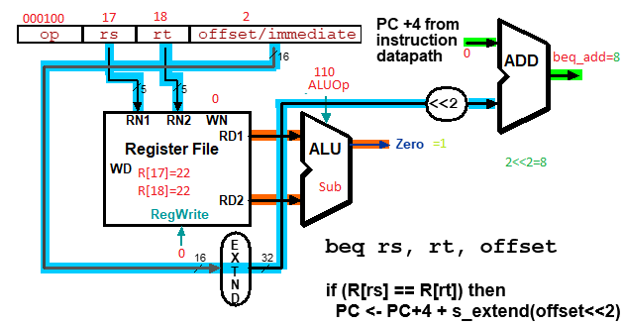

III.5.2 CODE
module beq_Datapath (rs,rt,offset,ALUOp,PC_plus_4, Zero,beq_add)

endmodule

III.5.3 LAB ASSIGNMENT
1) Write Verilog code to implement beq_Datapath module
2) Write testbenches to verify beq_Datapath module, simulate and verify the output data.

III.10.3 LAB ASSIGNMENT
Write testbenches to verify above blocks and attach waveforms.

III. LAB REPORT GUIDELINES

Students write up a report on the Verilog HDL implementation experiment projects created in this lab. The lab report should include Verilog code for the module under test, Verilog test bench code and a truth table results, and example data input and output to validate the experiment. Simulation Result in form of Simulation Capture Screen.

